Introduction to deep learning
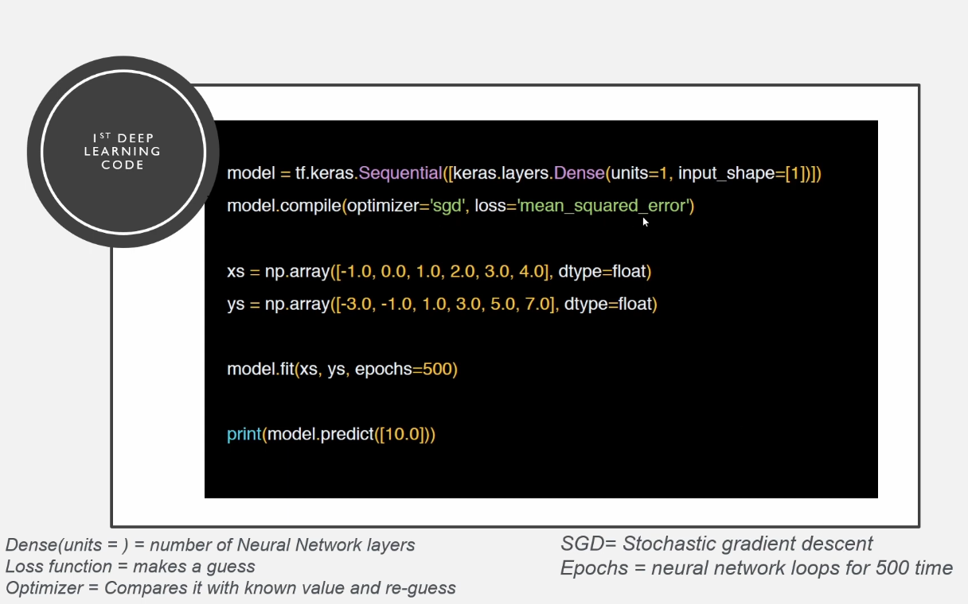
This is old code
sequentials means data
optimizer -> work for better result
loss function ->
activation function -> speed up process relu , tanh ,sigmoid ,max v many more

for regression we using mean squared error in loss function
in classification we using entropy in loss function

bais -> importance in model , give priority
trainable params-> jub algo chaly tou kin bato ko yaad rakna hai
non trainable ->

mnist and fashion manist

agar data k andar images multiclass classification hai tou we will use softmax activation func
if classification is multiclass classification we will use softmax activation
for binary we use sigmoid like we have to fin dout cat or dog these are two class so we will use sigmoid
for regression we use linear regressor

loss

multiple classofication -> loss -> sparse_categorical_crossentropy
binary classofication -> loss -> binary_crossentropy

kaggle token details

KGAT_c2877750511fc127e6c91cb39b2997cc

